DIS-CAN-Totem Pole-Eagle-Bear

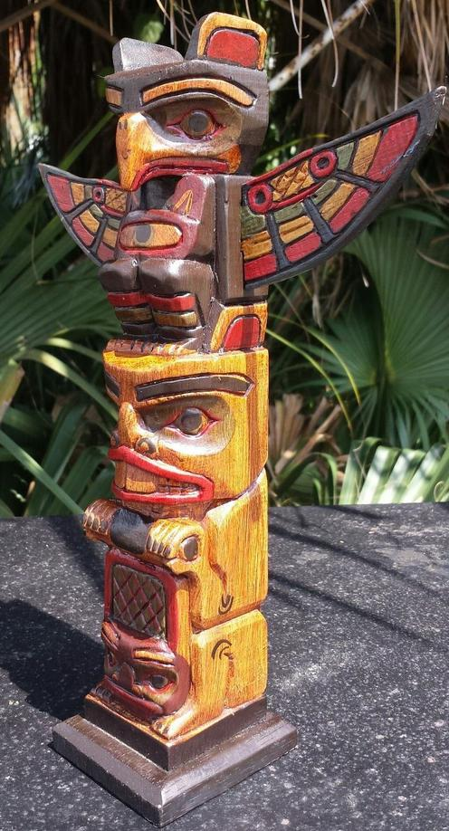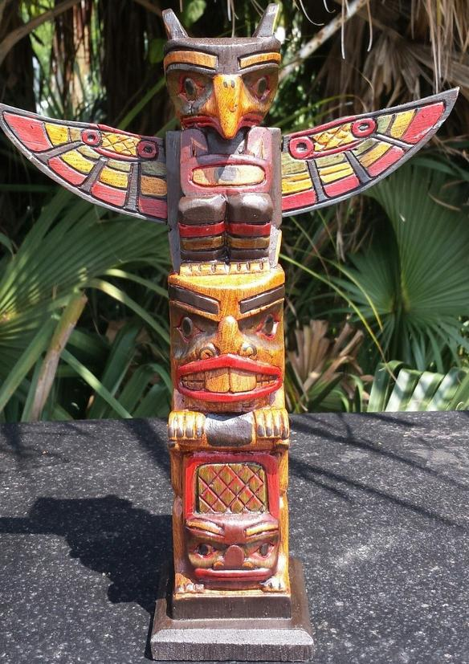

12" LONG X 3 INCH WIDE AT BASE & 10 INCH WINGSPAN

